Milestone 8: Add Multimodal Capabilities – Gradient Descenters
Current State of AdventureWorks Database Agent
Prior to the implementation of milestone 8, our database agent implemented the following features
- Natural language Understanding
  - Accepts business questions in natural language
- Function calling, incorporating tools into the prompts which
  - Retrieved database schema, execute SQL queries and returned data frames, checked for T-SQL syntax and validity
  - These were hardcoded python functions whose results were incorporated into the text prompts fed to the LLM, not function calling where the LLM itself would decide which to use. In future state, we will modify these to actual function calls
- RAG Enhanced Context Retrieval
  - Contextual information specific to the AdventureWorks2025DW database, including schema’s, business rules, join rules, patterns, and example queries
- Evaluation Framework to Ensure Accuracy & Privacy
With the addition of milestone 8, we added the following multimodality features, as well as built out a front end for using our AdventureWorks Database Agent. These features include
- Visualization generator
  - Supports 5 types of visualizations (line, bar, horizontal bar, pie, and heatmap) according to the type of user-query. This is generated in addition to the SQL query
- Vision Analyzer
  - Integrates OpenAI GPT-4o vision model to interpret the generated charts/graphs with specific prompts for each chart type to get contextual analysis
  - Extracts trends, patterns, and business insights from visualizations
- Redesigned agent framework
  - Redesigned framework orchestrates the multimodal pipeline, integrating the existing RAG-enabled SQL generation with the new visualization and vision analysis capabilities
- Streamlit Front End
  - Web application where users will type in their queries, and get back the SQL response, associated visuals, chart analysis & insights, as well as performance metrics & query history
Cross-Modal Consistency Testing
Validated that vision analysis aligns with actual data values by comparing AI insights against ground-truth data. Tested with the following suite and received an overall 89% level of accuracy in our moderate queries.
- Value Accuracy, Ranking Consistency, Trend Direction, Count Accuracy
For validation, you can examine the example shown in appendix A, where the query “Show me the monthly sales trends for 2013” generated a SQL statement, dataframe, and visualization, along with AI insights from analyzing the visual. The AI insights line up with a very high degree of accuracy with what is shown in the dataframe and the line-chart.
Modality Specific Prompting Strategies
For visual analysis, we implemented specific prompts for each type of chart. This is so that the user can receive tailored analysis optimized for a particular visualization.
- Line Charts
  - Focus: Trend analysis, pattern recognition, growth metrics, key inflection points
  - Output: Trends (direction), Patterns (seasonality), Key Points (peaks/troughs), Insights (business implications)
- Bar Charts (Vertical & Horizontal)
  - Focus: Ranking analysis, comparative insights, distribution patterns, outlier detection, market share estimation
  - Output: Leaders (top performers), Laggards (underperformers), Distribution (concentrated vs. spread), Insights (recommendations)
- Pie Charts
  - Focus: Market share percentages, segment dominance, balance assessment, growth opportunities
  - Output: Dominant Segments, Distribution balance, Small segments, Strategic insights
- Scatter Plots
  - Focus: Correlation strength/direction, cluster identification, outlier detection
  - Output: Correlation description, Pattern clusters, Outlier points, Business implications
Appendix:
Streamlit Demonstration of Agent + MultiModal Capabilities
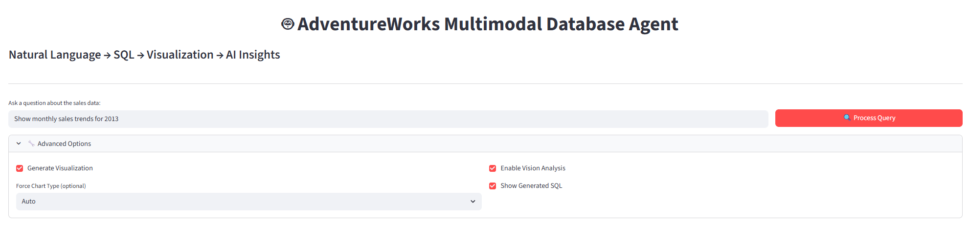
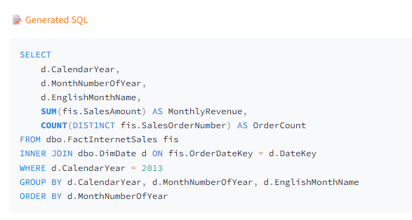
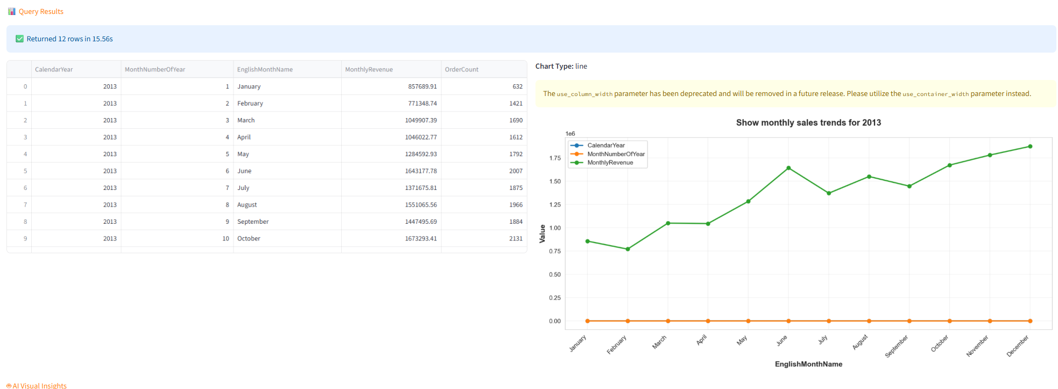
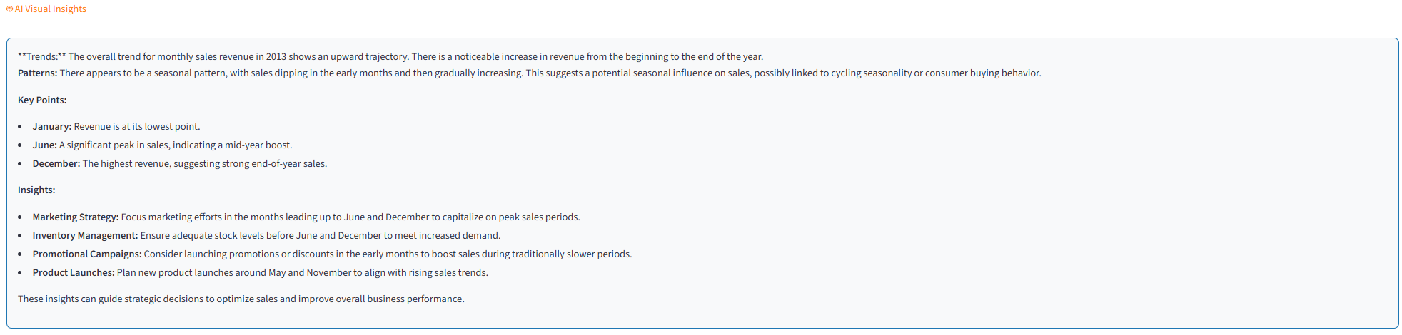
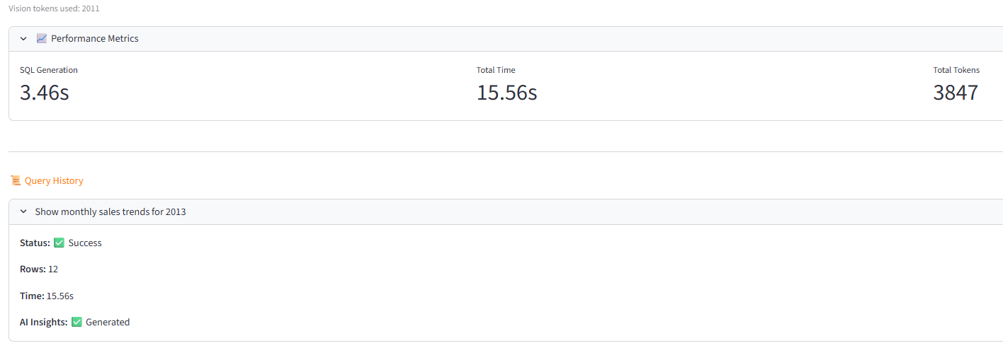

Visualization Generation Functions:
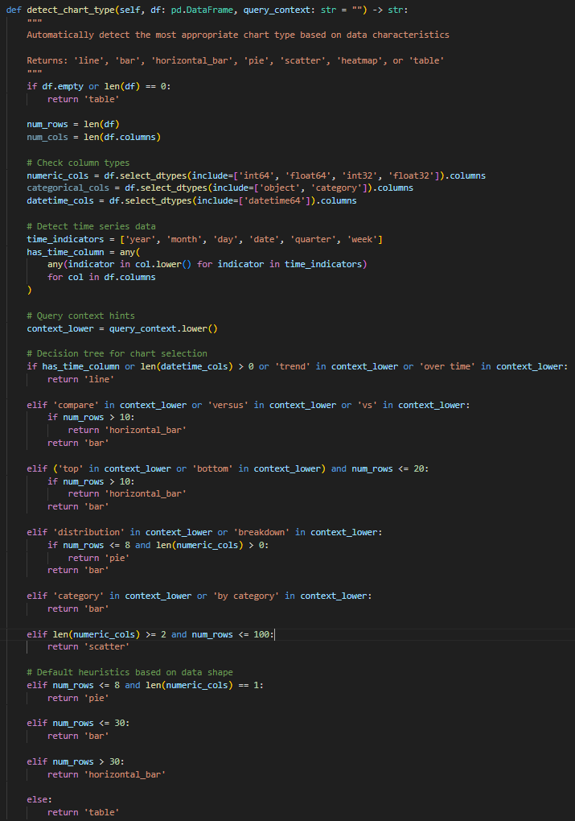

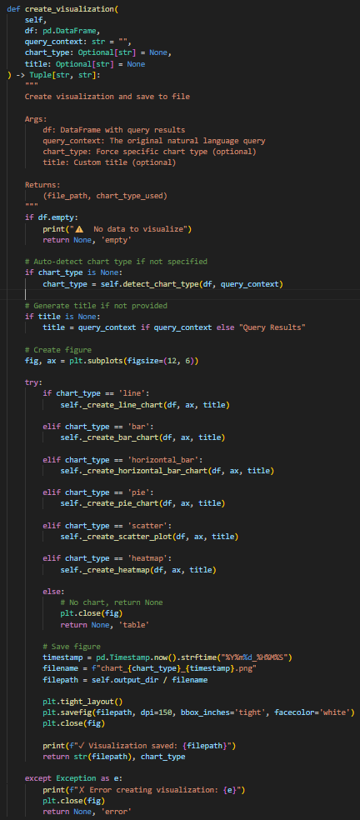
- 6 functions for each type of chart (line, bar, horizontal bar, pie, scatter, heatmap) – Not shown here
AI Vision Analysis
Encode Image to Base65 for API Transmission
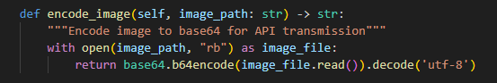

Create Analysis Prompts for Chart-Type Specific Prompts
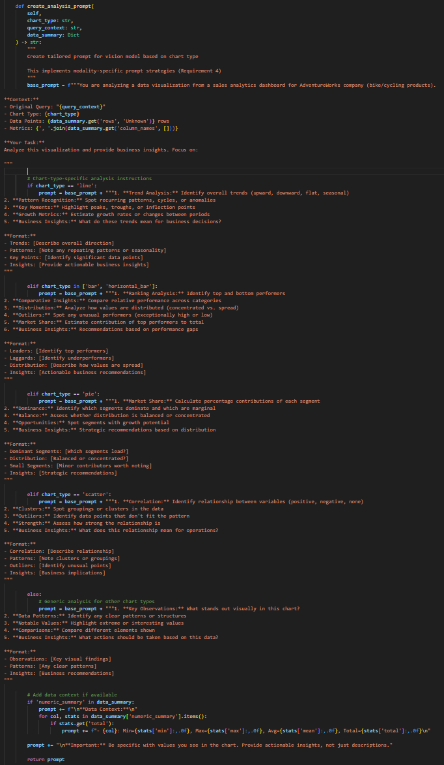
Analyze Visualizations
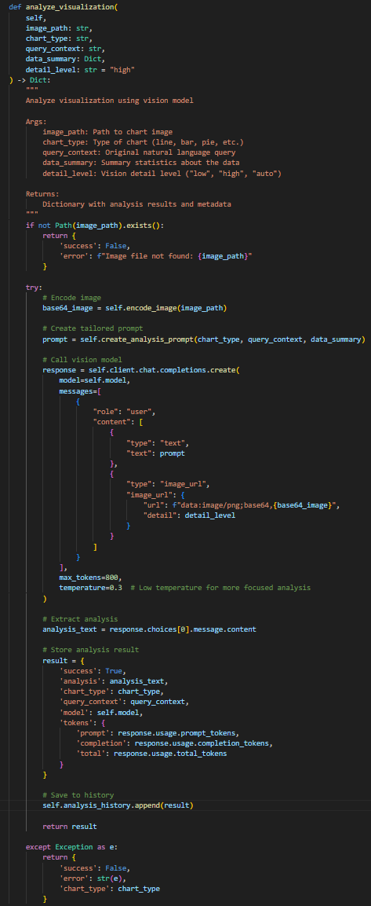
Compare Visualizations
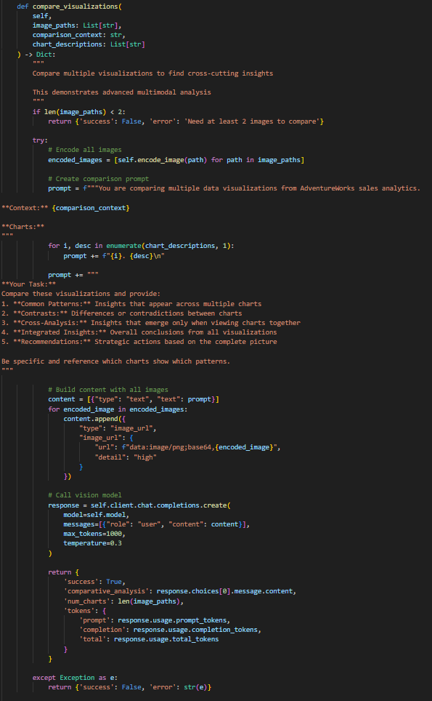

Performance Metrics
